Item and Price | Size and Quantity | Total
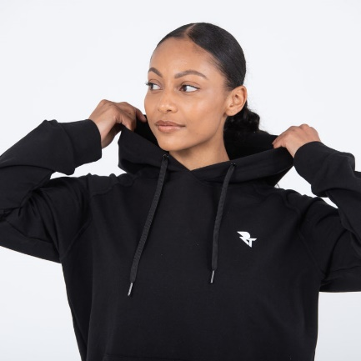  Hoodie - £35 | Size –  Quantity – | £ .
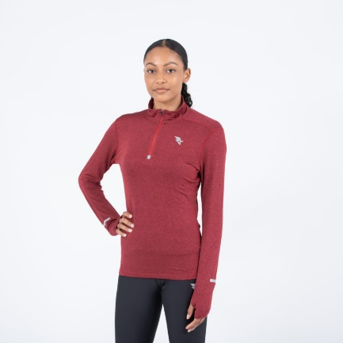  Half Zip - £33 | Size –  Quantity – | £ .
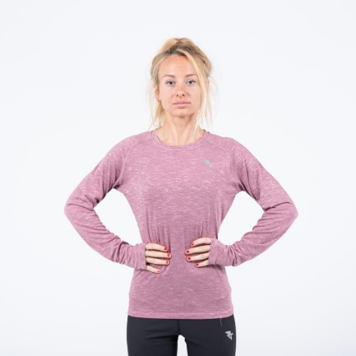  Long Sleeve - £31 | Size –  Quantity – | £ .
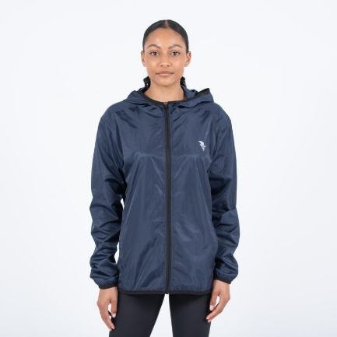  Lightweight Jacket - £41 | Size –  Quantity – | £ .
Red Training Tee – £27 | Size –  Quantity – | £ .
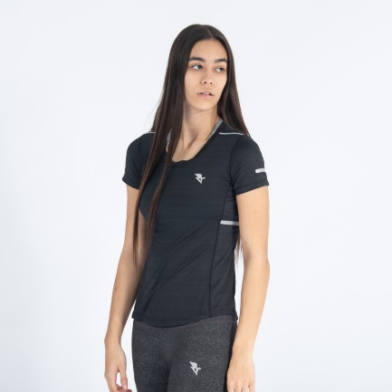  Black Training Tee - £27 | Size –  Quantity – | £ .
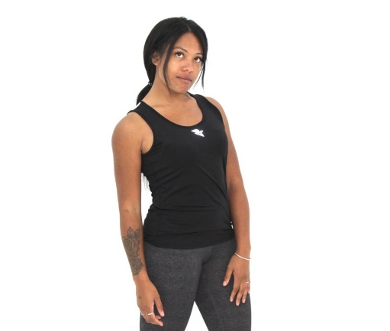  Racing Vest - £27 | Size –  Quantity – | £ .
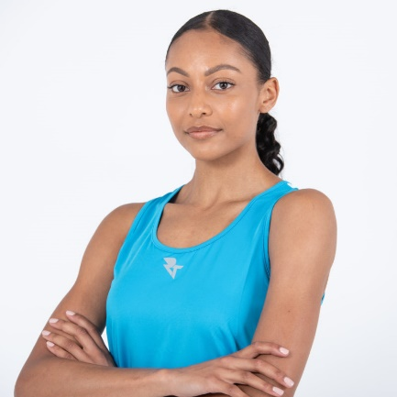  Training Vest - £27 | Size –  Quantity – | £ .
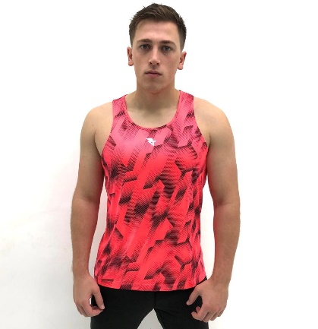  Racing Vest - £27 (men’s fit/sizing) | Size –  Quantity – | £ .
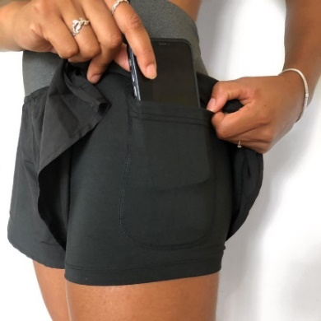  2 in 1 Shorts - £29 | Size –  Quantity – | £ .
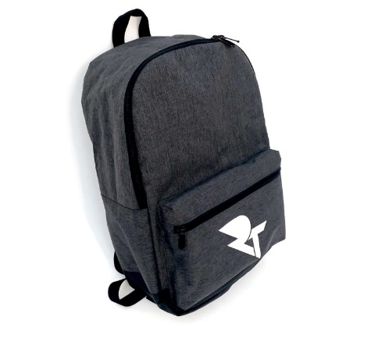  Rucksack - £25 | Quantity - | £ .

Name –

Address –

Date of Order –

Order Total  (plus P&P - £2.50 for 1 item,  £4 for 2+ items) | £

